Circular Motion
- Suppose an object is travelling at constant velocity. If you apply a force perpendicular to its direction of motion, its direction of motion will change.
- If this force is constant in magnitude and always perpendicular to the object’s motion, the path of the object will be a circle.
- The deviating force points towards the centre of the object’s circular path. The object’s acceleration is also directed towards the centre of the circle. The object’s acceleration at any time has a constant magnitude and its direction is tangential to its circular path.
- The direction of motion of the mass at any point is given by the tangent to the circular path at that point. Since its velocity is changing, the mass must be accelerating, meaning that there must be a resultant force acting on the mass – the centripetal force.
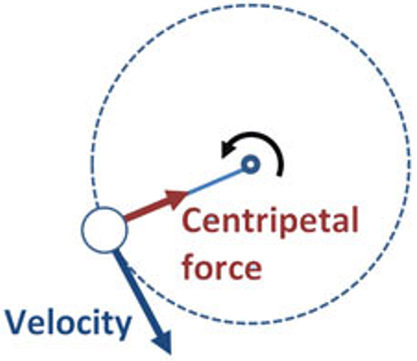
F_{c} = $\frac{{mv}^{2}}{r}$
a_{c} = $\frac{v^{2}}{r}$

Centripetal acceleration: The acceleration towards the centre of motion.
Centripetal force: The force required to keep the mass moving in a circular path.

Situation: | What provides the centripetal force:
Earth orbiting the Sun. | Gravitational force of attraction between the Earth and the Sun.
An object on the object’s surface. | Force of gravity on the object (weight).
Car rounding a bend on a road. | Frictional force between the tyres and the road.
Ball rolling down a banked curve. | Normal force of the ball.

Common examples of centripetal force:
- The frictional force acting on a coin resting on a moving turntable. The force preventing the coin from sliding off the turntable.
- The reaction fore between you and the side of the car door when rounding a bend. This force is directed towards the centre of the circular path taken by the car. It causes you to move in a circle with the car rather than go forwards in a straight line. The frictional force between you and the seat also assists as a centripetal force.
- The reaction force between clothes and the wall of a spin dryer. This causes the clothes to move in a circle but not the water which ahs no reaction force xerted on it because there are holes.
- The gravitational force of attraction between the Earth and the Moon. This force keeps the Moon, which has a tangential velocity, in a circular path around the Earth.

v = $\frac{2πr}{T}$ = 2πrf

Non-uniform circular motion:
- If an object moves in a circle that has a vertical plane, you must take the weight force of the object into account.
- The speed of the object isn’t constant because at the top of the loop the object has gravitational potential energy and kinetic energy, while at the bottom its potential energy is converted into extra kinetic energy.
- As it travels around the vertical circle, the object has 2 forces acting on it: the tension/friction/normal/etc force and the weight force, which always acts downward.
- The centripetal force is always the resultant of these 2 forces.

At the top of the circle: F_{c} = $\frac{{mv}^{2}}{r}$ = F₁ + mg
Where F₁ is the force supplied perpendicular to the motion that keeps the object moving in a circular path.

In the special case where the object travels across the top of the circle at minimum speed, F₁ is zero and the centripetal force is supplied entirely by the gravitational force.

At the bottom of the circle: F_{c} = $\frac{{mv}^{2}}{r}$ = F₁ – mg

Mass at the end of a string (bottom):
F_{c} = $\frac{{mv}^{2}}{r}$ = T – mg
Mass at the end of a string (top):
F_{c} = $\frac{{mv}^{2}}{r}$ = T + mg
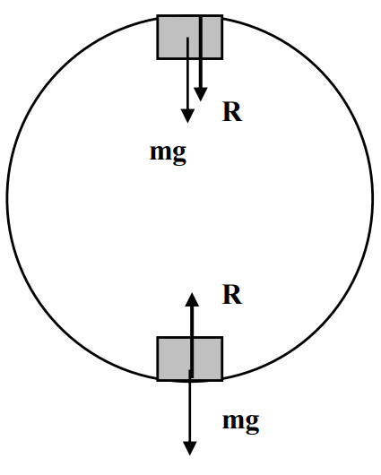
Standing in a revolving Ferris wheel (bottom):
F_{c} = $\frac{{mv}^{2}}{r}$ = R – mg
Sanding in a revolving Ferris wheel (top):
F_{c} = $\frac{{mv}^{2}}{r}$ = mg – R
Travelling over a humped road:
F_{c} = $\frac{{mv}^{2}}{r}$ = mg – R
A plane doing loop the loop (top):
F_{c} = $\frac{{mv}^{2}}{r}$ = R + mg

Banked tracks:
- When an athlete races around a bend or a car urns around a corner, the reaction force with the ground provides the necessary centripetal force.
- By banking a track or a road we can make use o the weight force and the reaction force with the ground to provide the centripetal force.
- This is particularly important at high speeds.

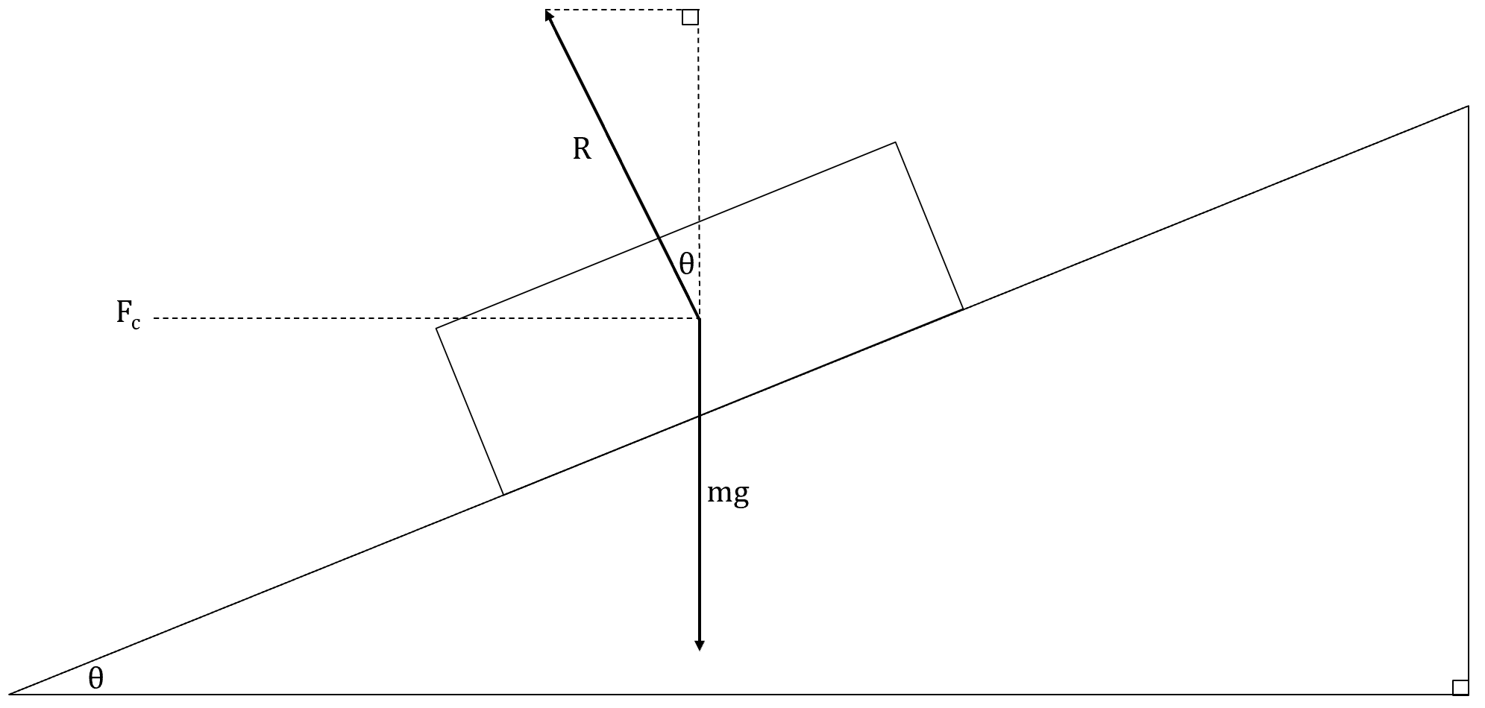
$$mg=Rcosθ since ∑F_{vertical}=0$$
i.e., The vertical component of R balances the weight force mg.
$$F_{c}=Rsinθ$$
i.e., The horizontal component of R provides the centripetal force.
$$sinθ=\frac{{mv}^{2}}{rR}, cosθ=\frac{mg}{R}$$
$$\frac{sinθ}{cosθ}=tanθ=\frac{mv^{2}}{rR} x \frac{R}{mg}=\frac{v^{2}}{gr}$$
Where:
- θ s angle of track to horizontal.
- v is optimum speed for banked track.
- r is radius of curvature.
- g is 9.8ms⁻².

Satellite motion:
- If a body is given horizontal velocity, it will fall with a curved path to the ground.
- If sufficient velocity is given, the curve of the object’s path will match the curvature of Earth.
- The object then falls around the Earth rather than onto the Earth.
- The velocity to achieve this is around 8kms⁻¹ or 29000kmh⁻¹.
- Satellites then may be considered as bodies that are simply in freefall around the Earth.
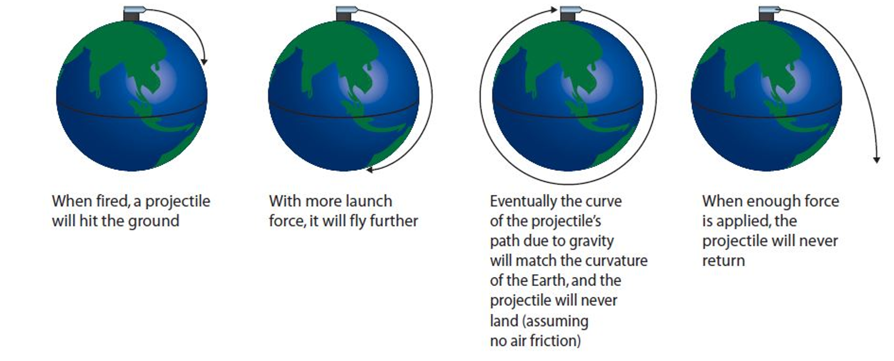

$$F_{c}=F_{g}$$
$$\frac{{mv}^{2}}{r}=\frac{GMm}{r^{2}}$$
$$v^{2}=\frac{GM}{r}$$
Where:
- v I velocity of satellite.
- m is mass of satellite.
- M is mass of central mass (e.g., Earth).
- r is orbital radius.

$$v=\frac{2πr}{T}$$
$$\frac{4π^{2}r^{2}}{T^{2}}=\frac{GM}{r}$$
$$\frac{r^{3}}{T^{2}}=\frac{GM}{4π^{2}}$$
$$\frac{T^{2}}{r^{3}}=\frac{4π^{2}}{GM}$$
$$T^{2}=\frac{4π^{2}}{GM}r^{3}$$

Our own sensation of weight is given to us by the reaction force that the ground exerts on us.
Apparent weightlessness can occur:
- In freefall – If you’re falling freely, there’s no reaction force exerted on you and thus apparent weightlessness.
- In orbit – Within an orbiting satellite, you’d eel weightless since you’re essentially in freefall. The weight force is the centripetal force.
- “Looping the loop” – If you’re moving in a vertical circle with sufficient velocity, you’ll experience weightlessness at the top (when $\frac{{mv}^{2}}{r}$ = mg).

Set 4
Q: An Olympic hammer thrower whirls the hammer, which is a round metal ball on the end of a short steel wire, rapidly in a circle in the preparation for the throw. If the athlete wants the hammer to travel due west, at what point should the athlete release the hammer?
When the tangential velocity of the metal ball of the hammer is West then the ball should be released. The ball will then, only be influenced by the gravitational force.
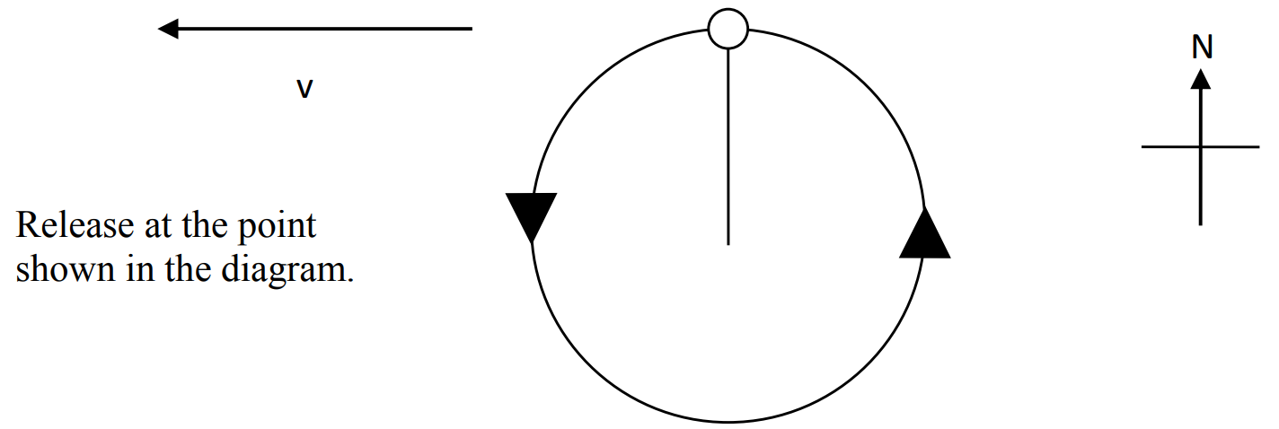
Q: Why does a sprinter running in a 200m event lean towards the centre of the curve he’s rounding?
Answer in terms of circular motion/projectile motion:
The sum of the forces on the runner is not equal to zero because the runner is moving in a circle. The 2 forces acting on the runner are mg and the reaction force. The mg force naturally passes through the centre of mass of the object because gravity acts on the centre of mass. The only force that needs to be deliberately placed through the centre of mass therefore is the reaction force. The reaction force consists of two parts or components. They are the normal force and the friction force. The angle formed when these two forces are added is the angle of lean of the runner.
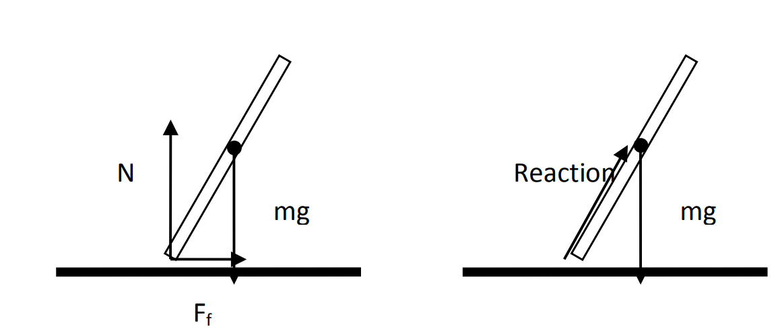
Answer in terms of torque:
The sum of the torques on the runner is equal to zero because the runner is not spinning or toppling. In order for the torques to equal zero all of the forces need to pass through the centre of mass. If both forces (mg and reaction pass through the centre of mass then there will be no radial distance about the pivot placed at the centre of mass. The Normal force counterbalances the weight force (mg). The friction force provides the centripetal force. If the frictional force is applied without the person leaning, the person will topple as their feet take the curve and their centre of mass continues in a straight line at a tangent to the circle. The same principle applies to bicycles rolling around a curve in a flat road.
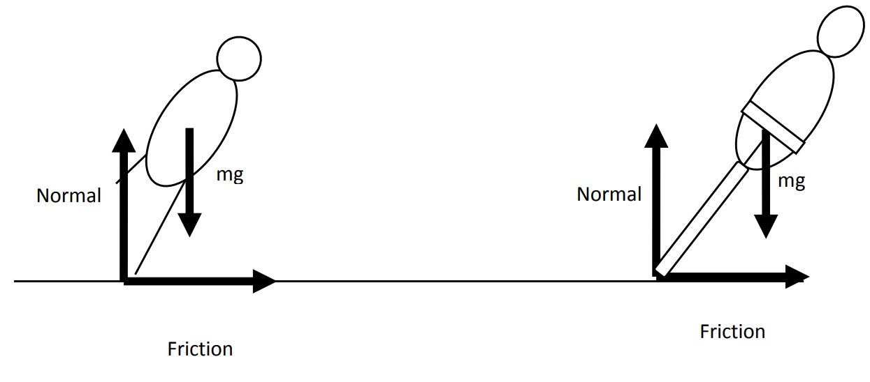
Q: A roller skater coasts around a curve at constant speed on a horizontal surface. What provides the centripetal force?
The roller skater travels around the curve because of friction. The roller skater would not be able to round the curve on ice. The skater can also lean towards the turn so as not to solely rely of friction.

Q: Use a diagram to clearly explain why engineers design banked curves on roads that have high speed limits.
Engineers make curves banked so that the normal force can contribute towards the centripetal force. If the curve was not banked, then the tyres would not be able to provided sufficient friction with the road surface to supply the centripetal force necessary to round the curve.
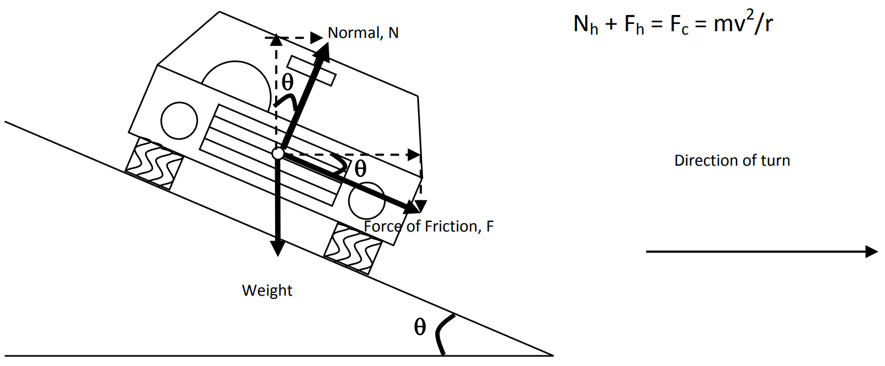
Q: The following diagram shows the schematic diagram (as viewed from above) of a proton synchrotron. This is a device for accelerating proton to high speeds in a horizontal circular path.
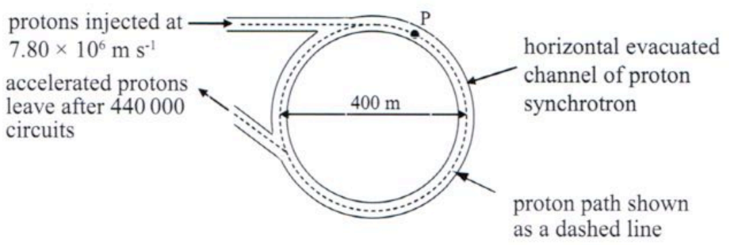
[a] Sketch a graph that shows how this force will have to change as the speed of the proton increases over the range indicated on the x-axis. Include an appropriate scale on the force axis.
Graph equation: F_{c} = $\frac{{1.67 x 10}^{-27}}{200}$ v²
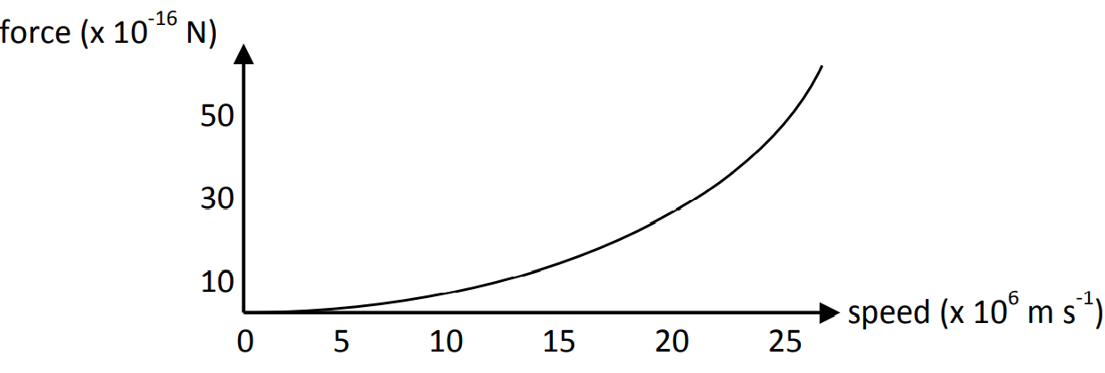
[b] Before reaching their final energy, the protons in the synchrotron travel around the accelerator 440000 times in 2.5s.
[i] What would occur to the vertical displacement of the proton in this time?
The proton will fall due to the effects of gravity.
[ii] Consider your answer above. What must be added to the synchrotron?
A field (electric or magnetic) is required to provide an upward force to counterbalance the protons weight.
In order to keep the proton circling horizontally, a vertical force must be applied to the proton in order to oppose its weight and hence prevent it losing height.
Opposing force required = weight of proton, w = m x g = 1.7 x 10⁻²⁷ kg x 9.8 ms⁻² = 1.67 x 10⁻²⁶ N upwards. This could be provided by an appropriate magnetic field or electric field.

Q: A string just supports a hanging brick without breaking. Explain why the string breaks if you set the brick swinging.
The tension in the string provides the centripetal force as well as supporting the objects weight.
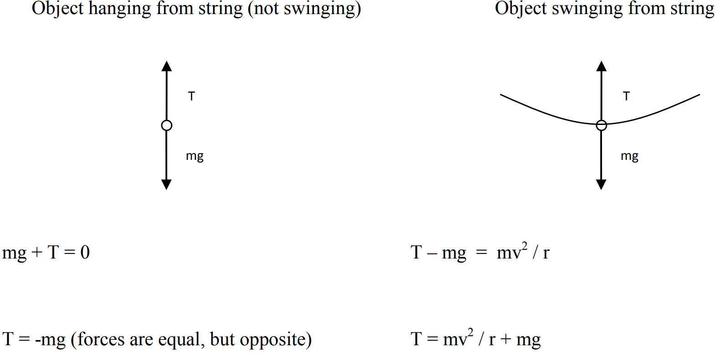
Based on the equations above, the tension is greater in the string when the object is swinging because the weight force and the centripetal force add and therefore the string is likely to snap.

Q: Explain why the water doesn’t fall out if the bucket transverses the top of the path at the minimum speed or greater in a vertical loop without spilling the water.
The bucket is being driven towards the centre of its circular path due to the presence of a resultant force providing a centripetal force. The water contents of the bucket is maintaining its inertia (Newton‘s First Law) and would feel‘ like it is being forced towards the outside of the circular path (the misconceived centrifugal force). Hence, the water remains in the bucket.
This is the same as the effect you feel as a passenger in a car which is turning a corner (much more noticeable if the car is taking the corner at speed) – the car is being pulled towards the centre of the turning circle and you feel like you are being pushed outwards, when in reality you are just feeling the car being pulled inwards.

Q: Does the bucket travel at a constant speed throughout its circular path in a vertical plane? Explain.
The bucket can travel at a constant minimum speed around its circular path, however the arm muscles would have to work a bit harder at different points of its path – the highest and lowest points of its vertical path would be the two extremes. If the arm muscles applied a constant tension force, then the speed would have to be regularly increased and decreased in order to maintain a vertical circular path.
There is also a loss in potential energy from the top of the path towards the bottom, which would suggest that, since the total amount of energy must remain constant, then there must be a gain in kinetic energy (and therefore speed) to compensate for this loss.

Q: You strap into a safety harness and take a rollercoaster ride. In one part of the ride, the rollercoaster car goes through a vertical loop at a speed of 14ms⁻¹.
[a] Describe what would occur to you if the car went through the loop faster than 14ms⁻¹. Explain.
If the roller coaster travels faster than 14.0 ms-1 more force will need to be supplied downwards to assist the mg force in providing the resultant centripetal force necessary to keep the carriage in the loop. This extra force will come from the normal force (reaction force) of the tracks in a downward direction.
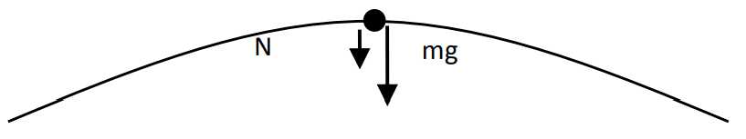
[b] Describe what would occur if the car went through the loop slower than 14ms⁻¹. Explain.
If the roller coaster travels slower than 14.0 ms-1 less force will need to be supplied downwards. A force will need to be provided upwards to reduce the effects of the mg force. This extra force upwards needs to come from the track mechanism, which depending on the track design may actually be physically impossible (if no safety devices).
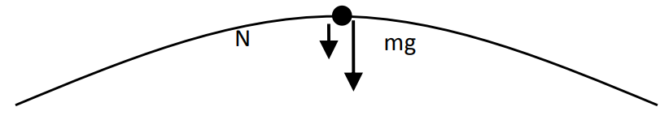
Passengers on a fairground ride resolve at a constant speed in a vertical circle of radius 3.6m. The ride operator has a choice of 2 speeds, low and high. At the high setting, passengers feel weightless at the top of the circle. At the low setting, the passengers resolve at half the high speed.
Free body diagrams showing the forces acting on a passenger at the top and bottom at each speed setting:
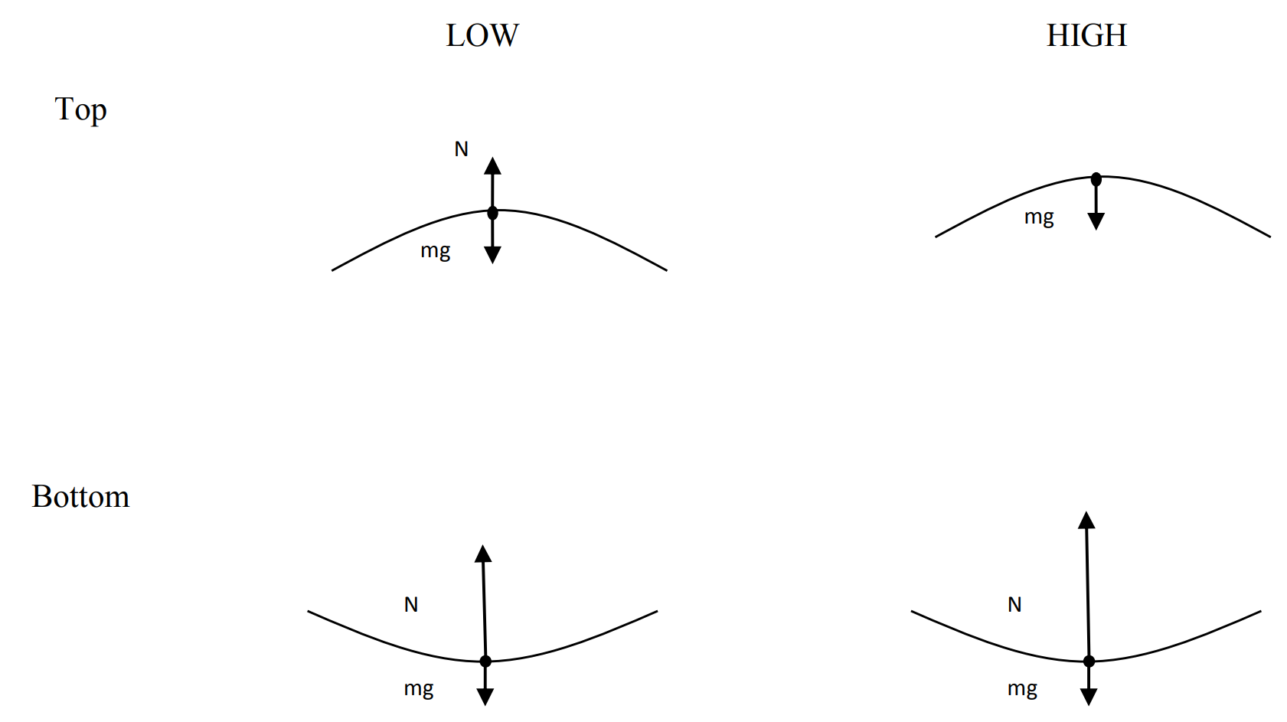
Q: A stone of mass 2.5kg is whirled in a vertical circle at the end of a 2m length of string.
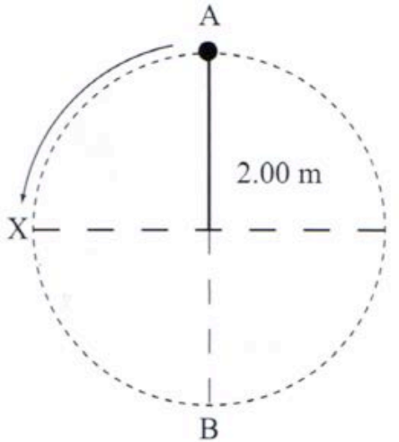
At which point, A, B or X, is the string most likely to break? Explain.
The string is most likely to break at the bottom (point B) since the tension is greater here. The tension must counterbalance weight and also provide the centripetal force.

WACE Study Guide
Q: Why does a bicycle rider lean inwards when travelling around a bend?
Bending allows the force of gravity to provide, through a reaction with the ground, a centripetal force into the corner.

Q: A circular glass bowl was partly filled with water and then placed on a spinning turntable. It was noticed that the level of the water curved towards the side of the container.
[a] What has caused this effect? Why?
The effect is caused by circular motion. The water bunches up against the solid wall which is able to provide a reaction force.
[b] Why is the slope of the water highest near the edge of the bowl?
At the edge, velocity is greater and hence a_{c} and F_{c} are greater. The steeper angle creates a reaction force with a greater horizontal component.
[c] If the experiment was repeated on the Moon, how would the result differ? Explain. Assume same rate of spinning and that the experiment is conducted in a room with normal atmospheric pressure.
The water would rise higher since gravity is weaker.

Q: 2 skaters joined hands and are skating rapidly around each other about a common point between them. Describe their movement at the instant they let go of each other.
They’ll move off at a tangent to their circular motion. This means they move off in opposite directions.

Creelman 2020
Q: Cars A and B are moving in a circle around a horizontal dual lane roundabout at a constant speed of 30kmh⁻¹ as shown in the diagram below.
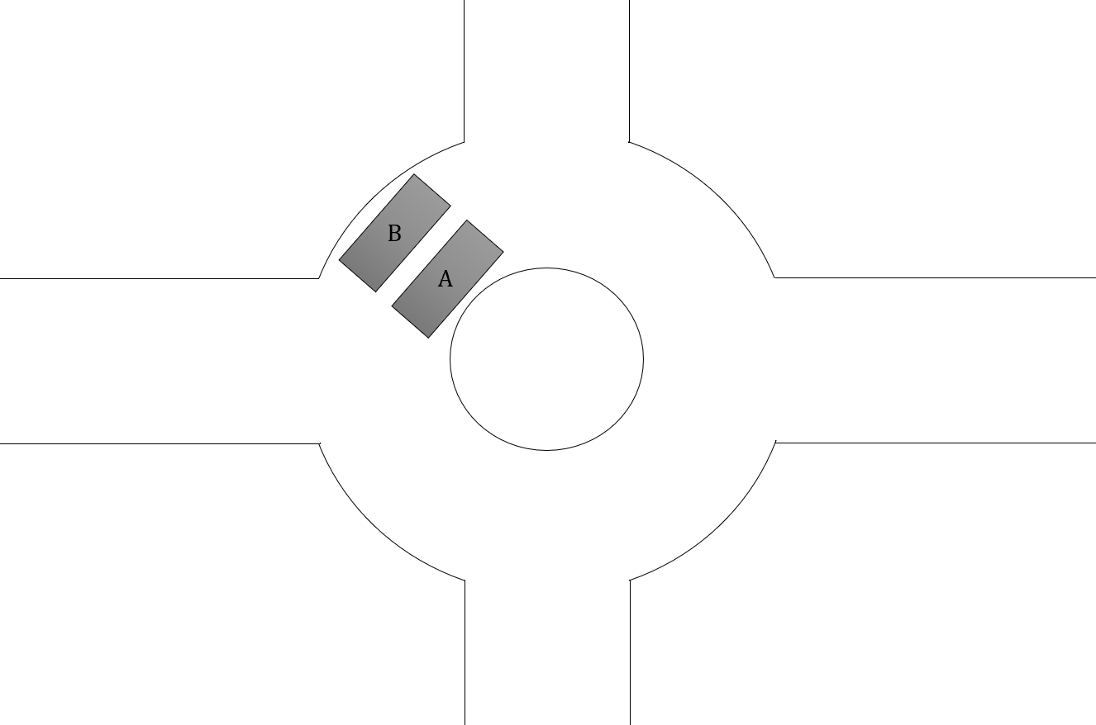
[a] Compare the accelerations of cars A and B. Include an equation in your answer.
The only acceleration is centripetal towards the centre of the circle. a_{c} = $\frac{v^{2}}{r}$ so if v is the same for both cars, a smaller radius will produce a larger acceleration. Hence, car A will have a larger acceleration than car B. Ratio $\frac{a_{A}}{a_{B}}$ = $\frac{r_{B}}{r_{A}}$.
[b] How can the roundabout be redesigned to enable cars to travel safely at a higher speed? Explain.
The roundabout could be banked which will allow a faster speed at the same radius for the same amount of friction from the tyres. Banking a road allows an extra force derived from the normal (road) force on the car as it’s now at an angle. The horizontal component of the normal force now contributes to the centripetal force, allowing a larger acceleration to act and a higher speed.

Revising Physics
On a roundabout a girl stands on the foot-plate. When the roundabout is rotating, the girl finds she must lean inwards at an angle to maintain her balance. This is because the frictional force on her feet and her normal reaction force combine to form a total reaction vector angled inwards.

Q: Why doesn’t the water fall out of the bucket in a vertically swinging bucket?
The bucket’s moving at a speed that requires a centripetal force greater than the weight force. Hence a reaction force is applied to the water, pushing it around in a circle rather than flying off at a tangent due to inertia. Hence, the water remains in the bucket and in circular motion.

Larger speed causes a larger tension which causes a larger centripetal force to maintain circular motion.

